First Draft to ICSSD-2025 (The Word Numbers In The Title no more Than 15 Main Words, Font Size 12, capitalize each first letter)
First A. Author¹, Second B. Author^{2,*}, Third C. Author³, and Fourth D. Author⁴
¹Affiliation: Dept, University, postcode Town/City, Country.
Email:
ORCID:
²Affiliation: Dept, University, postcode Town/City, Country.
Email:
ORCID:
³Affiliation: Dept, University, postcode Town/City, Country.
Email:
ORCID:
⁴Affiliation: Dept, University, postcode Town/City, Country.
Email:
ORCID:
*Corresponding author email: aabb@gmail.com ; WhatsApp: 00000000000
Leave one line, please.
Abstract
You can write your abstract here and delete the original text in this template. The abstract font style is Times New Roman 12. The abstract is one Para and consists of 200-250 words. Note that the abstract is structured from a short problem statement, objective, scope and solution method, and lastly, the important results and achievements. In the end, add a short recommendation. Citations are not allowed in the abstract. Avoid as much as possible the use of abbreviations in the abstract.
Keywords: 5 (five) to 6 (six) words, separated by a semicolon (;). It must be arranged in alphabetical order.
Leave one line, please.
- INTRODUCTION

The manuscript must be submitted in MS Word and formatted to A4 paper size. The margins on all sides are 25 mm. The text has to be written in Times New Roman, with a font size of 12, and all line spacing is 1.5 and justified.

All the citations must be as Author(s) [#]. Citations at the start of the sentence and within the text are without brackets. The citation at the end of the sentence should be in brackets (Ahmed et al., [17], and AlJenaby et al. [18]).

Ali and Jameel [26] mentioned that all new paragraphs must be tapped by 6.5 mm. The first Para after the heading or subheading is not tapped. However, Abbas et al. [20], Nori et al. [21], and Jessam et al. [22] have another opinion on the matter
Leave one line, please.
  - Subheading
Organize your writing into headings and subheadings. Only up to three levels of subheadings are allowed in your manuscript.
Leave one line, please.
    - Sub-subheading
If you have more than 3 levels, use A., B., …. Or i, ii, ….
- Deep learning
Aaaaa bbbb ….
- Manufacturing procedure
Aaaaa bbbb …..
Leave one line, please.
- TABLES AND FIGURE
  - Tables
All tables must be numbered, and the table title must be written above the table. The text inside the table has a font size of 10 Times New Roman and is in a single-line spacing format as in the sample in Table 1. Remember that the research table is three horizontal lines, and avoid vertical lines. Keep 6 points above and 6 points below the title, as in Table 1.
Table 1. Title of the table.
Writing | Style
Title | Times New Roman, font 12, bold, and Capitalize the first letter in each word
Author(s) names | font size 12
Affiliations | Times New Roman, font size 12
Abstract text, keywords, figure caption, table title, body text, references, | Times New Roman, font size 12
- HEADING | Times New Roman, font size 12, upper case, bold. 6 points before and 6 points after.
- Subheading | Times New Roman, font size 12, bold. 6 points before and 6 points after.
- Sub-subheading | Times New Roman, font size 12, bold. 6 points before and 6 points after
- Sub-sub-subheading | A, B, C for the fourth level of headings, Times New Roman, 12
Reference list | Times New Roman, font size 12.

Leave one line, please.
  - Figures
All figures, charts, and photos have to be in MS tools drawings, Excel, JPEG, or EPS format with 300 dpi. There are important points to consider in the figures.
- Inside the figures, the text, legend, labels, and numbers are all Arial size 9 or 10 points.
- The figure's source should be written, as shown in Figure 1.
- All figures must be original and editable. Figures of results are not accepted as pictures.

Figure 1: Variation of C_{PR} of bare D and bare AD at various Re. [Jessam et al. 22]
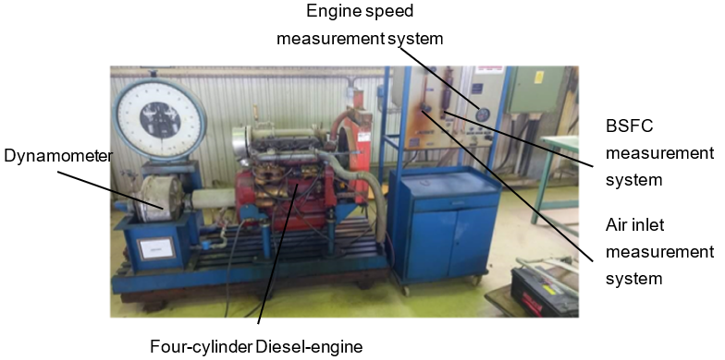
Figure 1. Figure caption
Leave one line, please.
- EQUATIONS
Use the Equation Editor in MS Word to write the equation in one pane and don't separate. Make sure that all equations are numbered sequentially. Please use common symbols. Never use the picture format of the equations.
You are advised to define each symbol after the equation. However, most journals are asking for a table of nomenclature in addition to the definition.
Ensure that you have defined any acronyms in the first appearance. In addition, you define all acronyms in the table of nomenclature.
Leave one line, please.
$S_{ε}=max\left(S_{l},S_{l}\left(I_{0}+I_{0}^{\frac{1}{2}}{\left(\frac{u}{u+S_{l}}\right)}^{\frac{1}{2}}{\left[1-exp⁡\left(-\frac{r}{l_{t}}\right)\right]}^{\frac{1}{2}}{\left[1-exp⁡\left(-\frac{t-t_{0}}{τ_{s}}\right)\right]}^{\frac{1}{2}}{\left(\frac{u}{S_{l}}\right)}^{\frac{5}{6}}\right)\right)$ (9)
Leave one line, please.
- CONCLUSIONS
To conclude the overall of the paper. Two to three lines about the main objective and topic of the paper, then the significant achievements and the results that are adding new contributions to the field of study. Do not repeat the methodology. Do not justify or discuss the results. One Para is advised to be added for the recommendations.
Leave one line, please.
ACKNOWLEDGMENT
The acknowledgment to the funder, stakeholder, co-researchers, or any other parties contribute directly or indirectly to producing the article and research.
Leave one line, please.
REFERENCES
Generally, the style is APA with manual adjustment by the author, like:
First Author Name, Second Author Name., all authors' names. (year). Article title. Journal full name, vol. ( issue no), pages. DOI

Example for journal paper:
[1] Lukman, R., and Glavic, P. (2007). Discussion on the key elements of a sustainable university. Clean Technologies and Environmental Policy, 9(2), 103-114. Doi: /////.

Example for book, thesis, report:
[2] Al-Kayiem, H.H. (2023). The future of solar power. NOVA Science Publishing. New York, USA.
[3] AL-Hakeem, S.S.H. (2020). Experimental investigation on natural polymer grafted single and hybrid nanoparticles based nanofluids for enhanced oil recovery process. PhD Thesis. Universiti Teknologi PETRONAS, Malaysia.

NOTES on the references:
- Use DOI with a web link. Example https://doi.org/10.1115/1.4034517, not 10.1115/1.4034517.
- Write the full name of the journal or the proceedings.
- Write the names of all authors.
- We are not accepting the list of references generated by software. You must submit a normal text of the list of references.

