First Draft to ICSSD-2026 (Word Numbers in the Title no More Than 15 Main Words, Use Times New Roman Size 12, Capitalize Each First Letter of Word)
First A. Author¹, Second B. Author^{2,*}, Third C. Author³, and Fourth D. Author⁴
¹Affiliation: Dept, University, postcode Town/City, Country. [Use TNR 12. All the paper is 1.5 line spacing]
Email:
ORCID:
²Affiliation: Dept, University, postcode Town/City, Country.
Email:
ORCID:
³Affiliation: Dept, University, postcode Town/City, Country.
Email:
ORCID:
⁴Affiliation: Dept, University, postcode Town/City, Country.
Email:
ORCID:
*Corresponding author email: aabb@gmail.com ; WhatsApp: 00000000000
Leave one line, please.
Abstract
You can write your abstract here and delete the original text in this template. The abstract font style is Times New Roman 12. The abstract is one Para and consists of 200-250 words. Note that the abstract is structured from a short problem statement, objective, scope, solution method, and lastly, the important results and achievements. In the end, add a short recommendation. Citations are not allowed in the abstract. Avoid as much as possible the use of abbreviations in the abstract.
Keywords: 5 (five) to 6 (six) words, separated by a semicolon (;). It must be arranged in alphabetical order.
Leave one line, please.
- Introduction [TNR 12, bold, 6 pt before and 6 pt after]

The manuscript must be submitted in MS Word and formatted to A4 paper size. The margins on all sides are 25 mm. The text has to be written in Times New Roman, with a font size of 12, and all line spacing is 1.5 and justified.

All the citations must be as Author(s) [#]. Citations at the start of the sentence and within the text are without brackets. The citation at the end of the sentence should be in brackets (Ahmed et al., [17], and AlJenaby et al. [18]).

Ali and Jameel [26] mentioned that all new paragraphs must be tapped by 6.5 mm. The first Para after the heading or subheading is not tapped. However, Abbas et al. [20], Nori et al. [21], and Jessam et al. [22] have another opinion on the matter
Leave one line, please.
  - Subheading [TNR 12, bold, 6 pt before and 6 pt after]
Organize your writing into headings and subheadings. Only up to three levels of subheadings are allowed in your manuscript.
Leave one line, please.
    - Sub-subheading
If you have more than 3 levels, use A., B., …. Or i, ii, ….
- Deep learning
Aaaaa bbbb ….
- Manufacturing procedure
Aaaaa bbbb …..
Leave one line, please.
- Tables and Figure [TNR 12, bold, 6 pt before and 6 pt after]
  - Tables
All tables must be numbered, and the Table title must be written above the table. The text inside the table has a font size of 12 Times New Roman and is in 1.5 line spacing format, as in the sample in Table 1. Remember that the research table is three horizontal lines, and avoid vertical lines. Keep 6 points above and 6 points after the title, as in Table 1.
Table 1. Style and font size in the ICSSD2026 template.
Writing | Style
Title | Times New Roman, font 12, bold, and capitalize the first letter in each word
Author(s) names | font size 12. Author name must: First name, Father's name or Initial, Family or Grandfather name [Hussain H. Al-Kayiem]
Affiliations | Times New Roman, font size 12
Abstract text, keywords, Figure caption, Table title, body text, references, | Times New Roman, font size 12
- Heading | Times New Roman, font size 12, Captilize first letter in each word, bold. 6 pt before and 6 pt after.
- Subheading or level 2 | Times New Roman, font size 12, bold. 6 points before and 6 points after.
- Sub-subheading or level 3 | Times New Roman, font size 12, bold. 6 pt before and 6 pt after.
- Sub-sub-subheading | A, B, C for the fourth level of headings, Times New Roman, 12
Reference list | Times New Roman, font size 12. 1.5 line spacing

Leave one line, please.
  - Figures
All figures, charts, and photos have to be produced in MS tools drawings, Excel, JPEG, or EPS format with 300 dpi. There are important points to consider in the figures.
- Inside the figures, the text, legend, labels, and numbers are all Arial size 9 or Calibri 10. Never mix. All figures and tables must use one word style.
- The figure's source should be written, as shown in Fig. 1.
- All figures must be original and editable. Figures of results are not accepted as pictures.

Figure 1. Variation of C_{PR} of bare D and bare AD at various Re. (Jessam et al. [22])
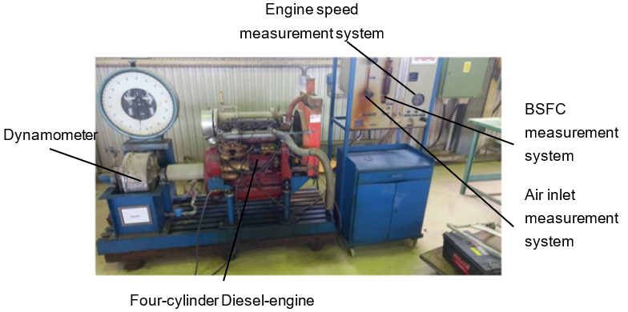
Figure 2. Figure caption
Leave one line, please.
- EQUATIONS
Use the Equation Editor in MS Word to write the equation in one pane and don't separate. Make sure that all equations are numbered sequentially. Please use common symbols.
You are advised to define each symbol after the equation. However, most journals are asking for a table of nomenclature in addition to the definition.
Ensure that you have defined any acronyms in the first appearance. In addition, you define all acronyms in the table of nomenclature.
Leave one line, please.
$S_{ε}=max\left(S_{l},S_{l}\left(I_{0}+I_{0}^{\frac{1}{2}}{\left(\frac{u}{u+S_{l}}\right)}^{\frac{1}{2}}{\left[1-exp⁡\left(-\frac{r}{l_{t}}\right)\right]}^{\frac{1}{2}}{\left[1-exp⁡\left(-\frac{t-t_{0}}{τ_{s}}\right)\right]}^{\frac{1}{2}}{\left(\frac{u}{S_{l}}\right)}^{\frac{5}{6}}\right)\right)$ (9)
Leave one line, please.
- Conclusions
This section is to conclude the overall paper. Two to three lines about the main objective and topic of the paper, then the significant achievements and the results that add new contributions to the field of study. Do not repeat the methodology. Do not justify or discuss the results. One Para is advised to be added for the recommendations.
Leave one line, please.
Acknowledgment
The acknowledgment to the funder, stakeholder, co-researchers, or any other parties that contribute directly or indirectly to producing the article and research.
Leave one line, please.
References
Generally, the style is
First Author, Second Author, All Authors' Names. (year). Article title. Journal full name, vol. ( issue no), pages. DOI

Example for a journal paper:
[1] Lukman, R., and Glavic, P. (2007). Discussion on the key elements of a sustainable university. Clean Technologies and Environmental Policy, 9(2), 103-114. DOI: /////.

Example for a book.
[2] Al-Kayiem, H.H. (2023). The future of solar power. NOVA Science Publishing. 1st Edition. New York, USA.

Example for thesis or dissertation:
[3] AL-Hakeem, S.S.H. (2020). Experimental investigation on natural polymer grafted single and hybrid nanoparticles based nanofluids for enhanced oil recovery process. PhD Thesis. Universiti Teknologi PETRONAS, Malaysia.

Example for conference paper:
[4] Al-Obaidi, A.S.M. (2018). This is how to cite proceedings/presented conference papers. Proceedings of the 1st Conference on Power, Manufacturing, and Materials (CPMM2018), 16-17 August, Penang, Malaysia, 1-9. DOI: /////.
NOTES on the references:
- Use DOI with a web link. Example https://doi.org/10.1115/1.4034517, not 10.1115/1.4034517.
- Write the full name of the journal or the proceedings.
- Write the names of all authors and do not use et al. in the list.
- We are not accepting the list of references generated by software. You must submit a normal text of the list of references.

